

40W Power Master & 100W Power Master
Power supply

Installation Manual

this Page intentionnally left blank

SOMMAIRE

general description 4
caractéristiques techniques 4
Connection 5
Connection to mains 5
Batteries connection 6
Link configuration depending on batteries capacity 7
iNTERNAL CONNECTION 8

general description
Powermaster power supply are available under two different models:
- Powermaster 40W, and
- Powermaster 100W

caractéristiques techniques
Dimensions :
- (H x W x D) : 245 x 60 x 60 mm

Electrical Caracteristics

Model | Consumption on mains | Voltage range
Powermaster 40W | < 50 W | 21,6V / 29V
Powermaster 100W | < 100 W | 21,6V / 29V

Depending on model, different batteries are available

Model | Batteries
Powermaster 40W | 4, 7 A.h
Powermaster 100W | 7-12-17-24 A.h

Connection

Connection to mains
 | Very important: to be read carefully  The company shall not be held responsible for non-adherence to instructions contained in this chapter.

Rules and recommendations for assembly
1. If the c.i.e. is connected to a 230v network that has an IT-type earthing, it is mandatory to insert an isolation transformer, its secondary windings being connected in TT-mode.
- The aforementioned isolating transformer must be fitted in a housing outside the equipment. This transformer must comply with the corresponding recommendations of the EN 60950 standard and must be built in such a way that a single insulation fault and its consequences do not cause high voltage on the s.e.l.v low-voltage windings.
- A double-pole circuit breaking device should be provided to separate the equipment from its power supply in order to maintain the security system.
This circuit breaking device may be a 230v/50hz double-pole residual current circuit-breaker (10A minimum, 30mA leakage rating).
- We recommend that a dedicated earth system be used for the fire safety equipment.
Connection to the mains cable:
the mains lead should have double insulation and must
- be tied firmly by the means of the cable-gland,
- have all three conductors tied together with a tie-wrap
The tie-wraps are provided with the hardware (see figure below).
TYPE OF CABLE:
- Stranded with crimped terminals or solid (with double insulation).
- Its insulation should be in synthetic rubber (H05RR-F) or in polyvinylchloride (H05VV-F or H05VVH2-F2).
- section: 1.5mm² to 4mm²
- The wiring should be performed in accordance with local applicable standards
IT TYPE EARTHING: Energy distribution system without a direct link to the ground, the, exposed conductive part of the installation being earthed

Electrical connections
In order to connect the power network, proceed as follows:
- Make sure the mains cables are not live.
- Take the fuse out of the terminal block and check its marking.
- Connect the mains cables to the terminal block:
Brown conductor: Live
Blue (may be other colour) conductor: Neutral
Yellow/Green conductor: Earth
- Set the fuse back.
- For EMC compliance, fit the supplied ferrite Absorber (Wurtz 742 700 90 or equivalent). Mains cable shall make a turn.

Figure 1 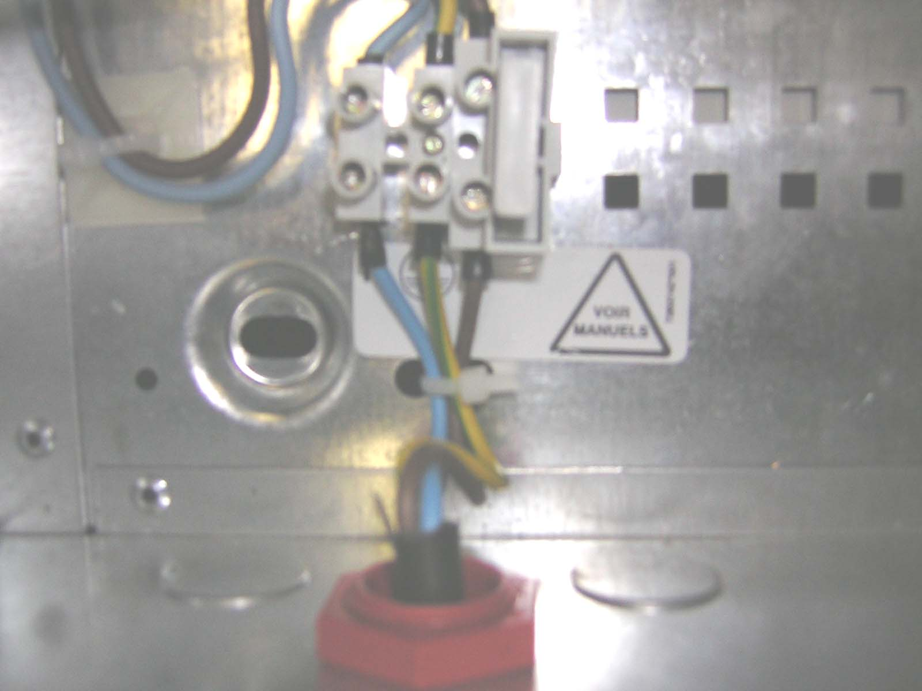 [PH339111]

Fuse selection
- Powermaster 40W
 |  | FUSE caracteristics
Mains | DOMINO P/F | 5x20 2A time lag. HPC | T2 HPC 250
Battery | BATTERIE | 5x20 2A fast | F2L 250V

- Powermaster 100W
 |  | FUSE caracteristics
Mains | DOMINO P/F | 5x20 3,15A time lag. HPC | T3.15 HPC 250
Battery | BATTERIE | 5x20 5A fast | F5L 250V

Batteries connection

 | The batteries can be installed only after the installation of the cabinet.

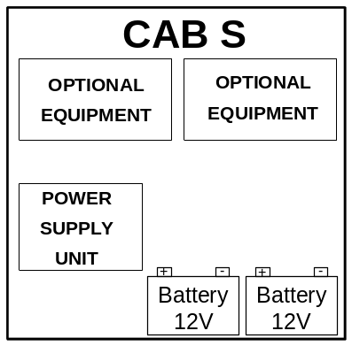  Figure 2 [PC370411] | The 1000 cabinet S enables to realize:  A power supply of 40W or 100W  two 12V / 4Ah, 7Ah or 12Ah batteries
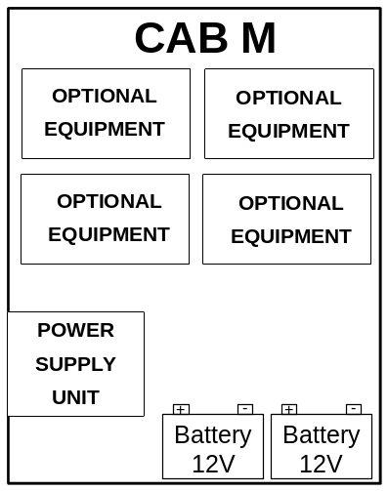  Figure 3 [PC370411] | The 1000 cabinet M enables to realize:  A power supply of 40W or 100W  two 12V / 4Ah, 7Ah, 12Ah, 17Ah or 24Ah batteries

The batteries are placed in the cabinet
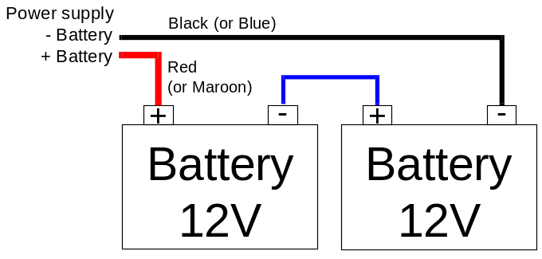
Figure 4 [PC369911]

The batteries are fitted in a battery cabinet (this configuration is not covered in the certification)
- If the panel cabinet and the battery cabinet are mechanically linked.
→ Proceed as described in previous paragraph.
- If the cabinets are not mechanically linked :
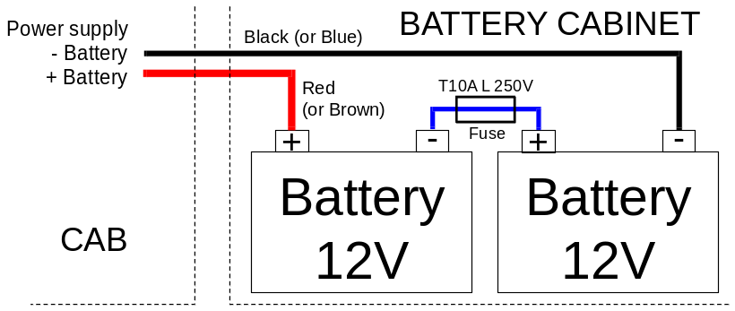
Figure 5 [PC369911]

Observe the polarity of the polarity of the batteries and the colour of the cables.
Connect the wires to the batteries once they are installed

Link configuration depending on batteries capacity

Link | Description | Link configuration
Link | Description | Alim. 100W | Alim. 40W
ST1 | Batteries load | 24 A.h | 7 A.h
ST2 | Batteries load | 17 A.h | 4 A.h
ST3 | Batteries load | 12 A.h | 2 A.h
ST4 | Batteries load | 7 A.h | -
ST5 | Batteries load | 4 A.h | -
ST6 | Stop batteries charge in case of alarm | Functional
ST7 | Stop batteries charge in case of alarm | Not functional

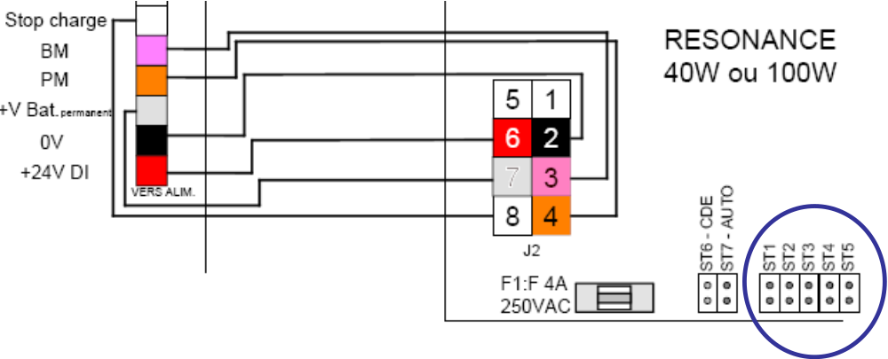
Figure 6 [PC369911]

iNTERNAL CONNECTION
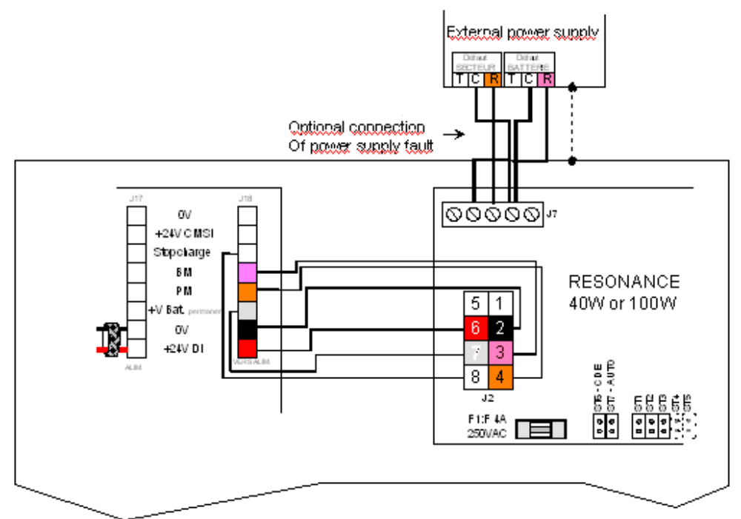
Figure 7 [PC366211]

this Page intentionnally left blank
this Page intentionnally left blank

AVERTISSEMENT : Soucieux de l'amélioration constante de nos produits qui doivent être mis en oeuvre en respectant les réglementations en vigueur, nous nous réservons le droit de modifier à tous moments les informations contenues dans ce document. Le non-respect ou la mauvaise utilisation des informations contenues dans ce document ne peut en aucun cas impliquer notre société. Dans la mesure où les textes, dessins et modèles, graphiques, base de données reproduits dans ce guide seraient susceptibles de protection au titre de la propriété intellectuelle et dès lors que le Code de la Propriété Intellectuelle n’autorise, au terme de l’article L122-5 2° et 3° a), d’une part, que « les copies ou reproductions strictement réservées à l’usage privé du copiste et non destinées à une utilisation collective », et, d’autre part, que « les analyses et les courtes citations » dans un but d’exemple et d’illustration, sous réserve que soient indiqués clairement le nom de l’auteur et la source, toute représentation ou reproduction intégrale ou partielle faite sans le consentement des auteurs ou de leurs ayants droit ou ayants cause est illicite » (article L122-4). Cette représentation ou reproduction, par quelque procédé que ce soit, constituerait donc une contrefaçon sanctionnée par les articles L335-2 et suivants du Code de la Propriété Intellectuelle.

